Triangle Water Partnership History

The Triangle Water Supply Partnership (TWP) was formed in 2018 by 13 jurisdictions and water systems in the Triangle, wishing to continue and strengthen the valuable water supply planning work and collaborative efforts initiated by the Jordan Lake Partnership (JLP). Signature projects of the JLP include an award-winning Regional Water Supply Plan as well as an Interconnection Model. The timeline for these projects is shown in Figure 1.

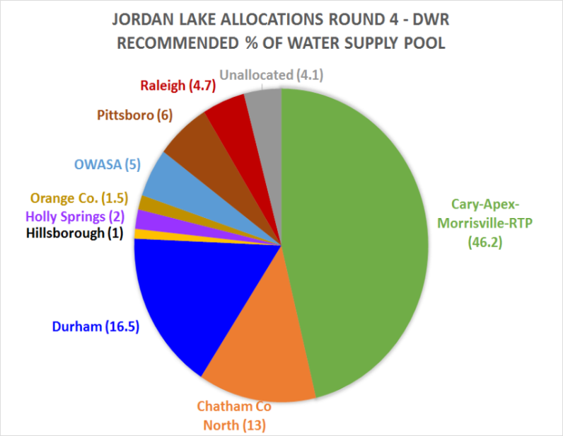
- The Triangle Regional Water Supply Plan (completed in 2014) included peer-reviewed demand projections through 2060 to develop proposed Jordan Lake water supply allocation requests (shown in Figure 1). The analysis confirmed the requested allocations would not harm downstream water users, even in the event of droughts as severe as any recorded during the past 80+ years. The plan also outlined recommended paths forward for additional supply opportunities. Figure 2, shows the timeline of the allocation process
Figure 2. Jordan Lake Allocation Requests
- Simultaneously, the Interconnection Model was also developed which identified existing and proposed interconnections between systems and modeled capacities and demands. The purpose of the study was to identify supply alternatives and responses to outages or water shortages. It was the first time regional water system information has been complied and mapped to the hydraulic model level of detail. Figure 3 shows an overview of the interconnections modeled.

Figure 1. Timeline for Jordan Lake Partnership milestones
Partners Submit Letter of Interest in JL Allocation Round 4
EMC Action on JL Round 4 Allocations
TWP Formed With New Members
Final JL Round 4 Application
Triangle Regional Water Supply Plan (Draft 2013-Final October 2014)
Jordan Lake Partnership Formed

2009 2010 2011 2012 2013 2014 2015 2016 2017 2018 2019
Interconnection Study Phase 2 complete
Interconnection Study Phase 1 complete

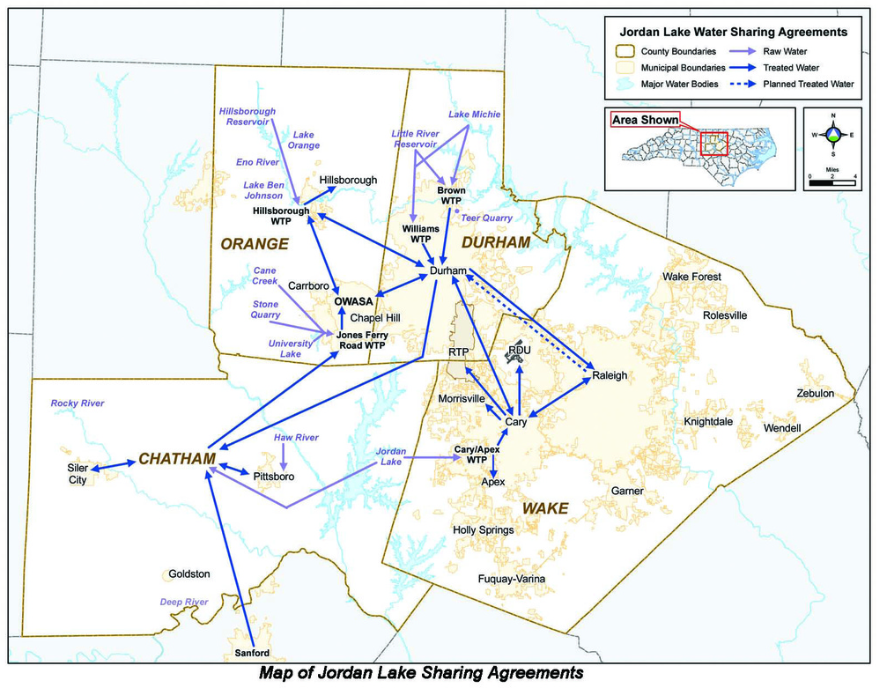
Triangle Water

Supply Partnership Future

After the Jordan Lake Round 4 allocations were awarded, JLP redefined itself as the Triangle Water Supply Partnership, adding new members Johnston County and Harnett County. The new partnership intends to improve upon the previous work of the JLP and has identified the following projects as key opportunities for the next five years:
Figure 3. JLP Interconnection Study Overview Map

Regional Water Shortage and Response Planning: This project will begin with an update to the interconnection model to include major changes and new partners. Once updated, the model will be used to further understand the capabilities and limits of the Triangle Region's present water supply network. This effort supports regional reliability, resiliency, and redundancy.
​_______
Triangle Regional Water Supply Plan: This plan will be much more than a simple update of the original JLP plan. This new plan will include the larger TWP membership and a comprehensive evaluation of potential water sources.
_______
Emergency Spill Response and Mitigation Plan Coordination: TWP is developing an appreciation for how each supplier's responses rely on coordination with partners in the region, in order to lay the framework for that coordination and pre-planning.
_______
Interconnections Model Maintenance: The Interconnections Model will be updated approximately every five years. The Regional Water Shortage and Response Planning Project will effectively update JLP’s Interconnections Model; therefore, the first anticipated occurrence of this project is FY2024.
_______
See www.trianglewaterpartnership.org to find out more!

